Daniel Williamson

Project #8

5/5/17

EE 222

Project Overview

Purpose:

The purpose of this project was to implement a binary search tree. In this project we simple needed to pass some tests created by the instructor.

Approach:

To being, I needed to understand what was required of the project. Binary search trees are not very complicated, but finding certain nodes like the successor node or removing a parent node can be difficult. To begin, I simple went down the line of methods that were already pre-defined by our instructor. We just needed to add the logic.

Results:

This is a photo of my program passing all the tests:

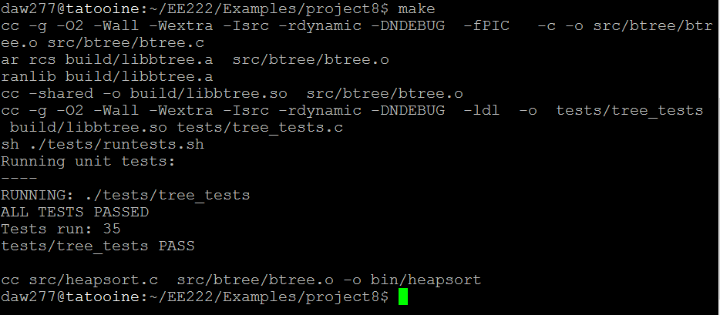

Conclusion:

In conclusion, this was a difficult lab for me. I had a good understanding of how a binary search tree works. But trying to code to find the successor node and removing a node by value made this project a bit difficult for me. To overcome this I spoke with a few classmates to understand how they solved the issue.